SOCIAL ANALYTICS ASSIGNMENT-1

SATVIK NIGAM

R100217105

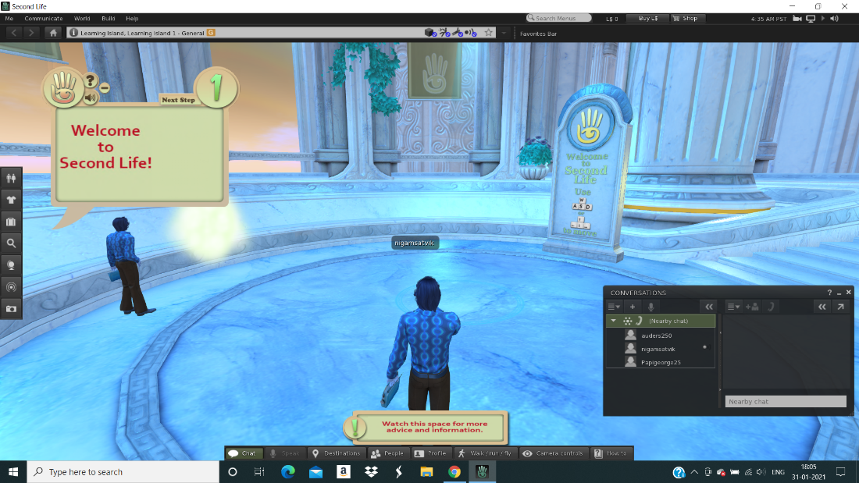

Intro Page and setup: This is the intro page which makes us familiar with the interface and controls of the application. There is a dedicated chat box to chat with other fellows

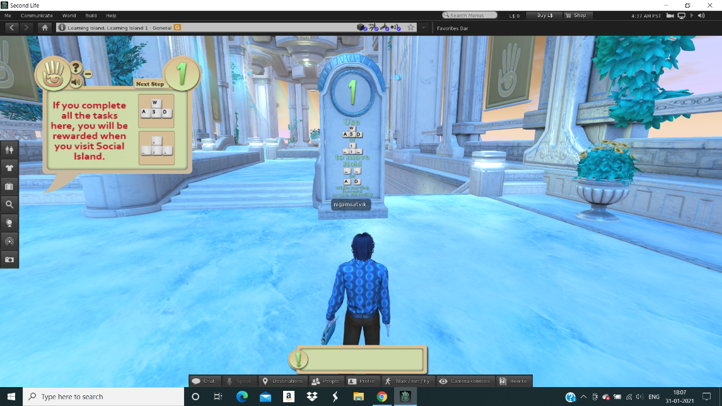

Controls: The application is completely controlled with a combination of keyboard and mouse. W,A,S,D/arrow keys to move and E to jump/ fly. The mouse will be useful in viewing different camera angles and panning to a bigger area

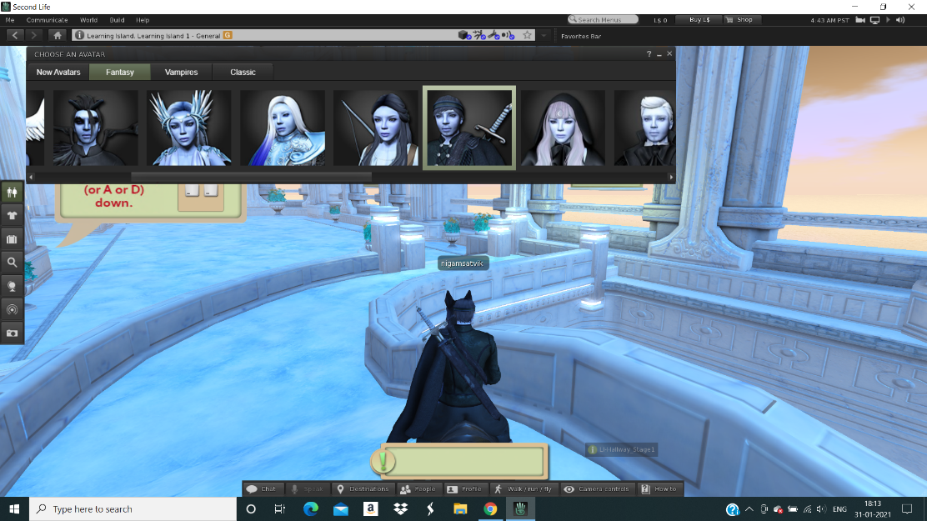

Avatar Selection: In Second Life, my character/avatar is based on a mix of mythological and fantasy-based characters. I am a particular fan of the retro themed design which is inspired from several historical and horror dramas.

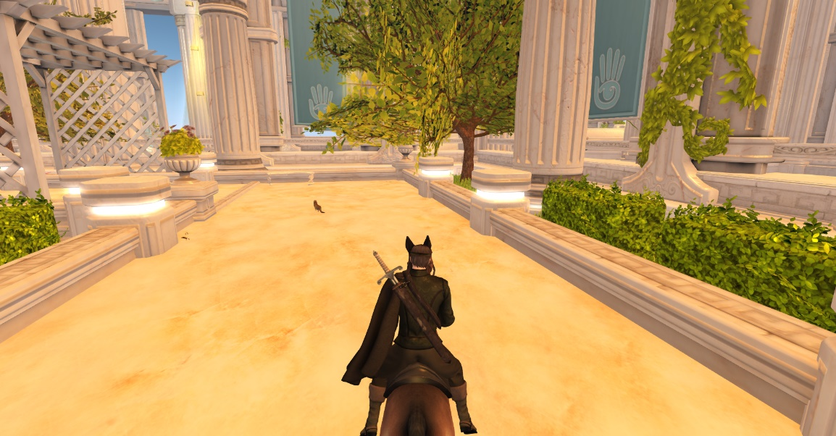

There are several different locations/ maps to choose from and walk around. The location shown in the image above is the default setup.

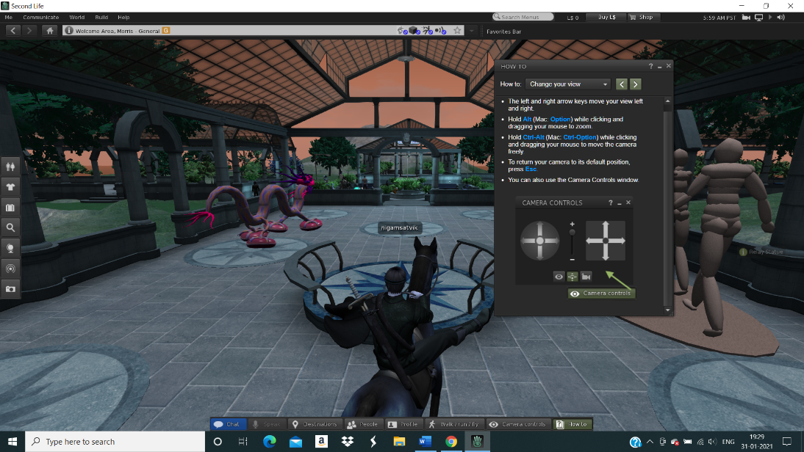

We can use a combination of Alt and Mouse Buttons to pan the camera angle or set a wider view. We also have an option of switching to first person or third person view.

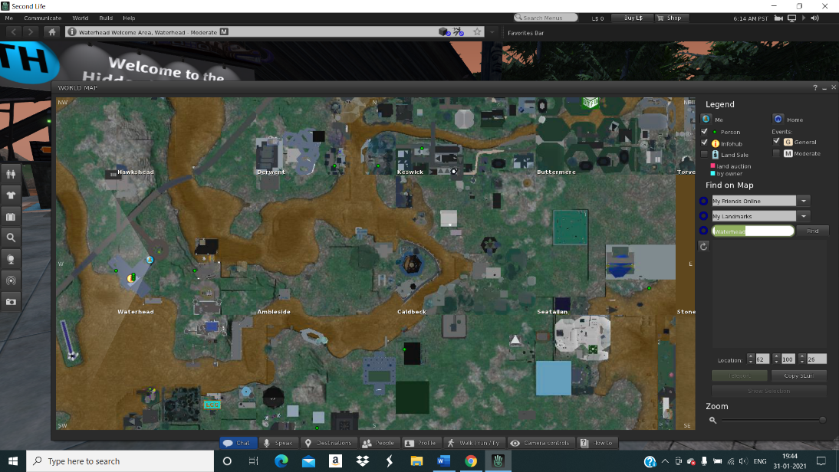

There is a map view to teleport to the desired locations which are categorized based on population density, terrain, complexity etc.